Assignment – 4

Index .html
<!DOCTYPE html>
<html lang="en">
<head>
<meta charset="UTF-8">
<meta name="viewport" content="width=device-width, initial-scale=1.0">
<title>Advanced Calculator</title>
<style>
.title {
text-align: center;
color: white;
margin-bottom: 20px;
font-size: 26px;
letter-spacing: 1px;
}
* {
margin: 0;
padding: 0;
box-sizing: border-box;
font-family: "Segoe UI", sans-serif;
}
body {
height: 100vh;
display: flex;
justify-content: center;
align-items: center;
background: linear-gradient(135deg, #5f72bd, #9b23ea);
}
/* Calculator Container */
.calculator {
<h2 class="title">Simple Calculator</h2>
width: 450px;
padding: 30px;
border-radius: 25px;
background: rgba(255, 255, 255, 0.12);
backdrop-filter: blur(20px);
box-shadow: 0 25px 50px rgba(0, 0, 0, 0.35);
animation: fadeIn 0.6s ease-in-out;
}
/* Animation */
@keyframes fadeIn {
from { opacity: 0; transform: scale(0.9); }
to { opacity: 1; transform: scale(1); }
}
/* Display */
.display {
height: 80px;
background: #111;
color: #00ffd5;
font-size: 28px;
text-align: right;
padding: 20px;
border-radius: 15px;
margin-bottom: 25px;
overflow-x: auto;
}
/* Buttons Grid */
.buttons {
display: grid;
grid-template-columns: repeat(4, 1fr);
gap: 15px;
}
/* General Button */
button {
padding: 20px;
font-size: 20px;
border-radius: 15px;
border: none;
cursor: pointer;
transition: all 0.2s ease;
background: rgba(255,255,255,0.2);
color: white;
}
/* Hover */
button:hover {
transform: translateY(-3px);
background: rgba(255,255,255,0.35);
}
/* Click */
button:active {
transform: scale(0.95);
}
/* Special Buttons */
.operator {
background: #ff6b6b;
}
.equal {
background: #00e676;
color: black;
grid-column: span 2;
}
.clear {
background: #ff3d3d;
}
.delete {
background: #ffa502;
}
/* Responsive */
@media (max-width: 500px) {
.calculator {
width: 95%;
}
}
</style>
</head>
<body>
<div class="calculator">
<h2 class="title">Simple Calculator</h2>
<div id="display" class="display">0</div>
<div class="buttons">
<button class="clear" onclick="clearDisplay()">C</button>
<button class="delete" onclick="deleteLast()">DEL</button>
<button class="operator" onclick="append('/')">÷</button>
<button class="operator" onclick="append('*')">×</button>
<button onclick="append('7')">7</button>
<button onclick="append('8')">8</button>
<button onclick="append('9')">9</button>
<button class="operator" onclick="append('-')">−</button>
<button onclick="append('4')">4</button>
<button onclick="append('5')">5</button>
<button onclick="append('6')">6</button>
<button class="operator" onclick="append('+')">+</button>
<button onclick="append('1')">1</button>
<button onclick="append('2')">2</button>
<button onclick="append('3')">3</button>
<button onclick="append('.')">.</button>
<button onclick="append('0')">0</button>
<button class="equal" onclick="calculate()">=</button>
</div>
</div>
<script>
let display = document.getElementById("display");
/* Append values */
function append(value) {
if (display.innerText === "0") {
display.innerText = value;
} else {
display.innerText += value;
}
}
/* Clear */
function clearDisplay() {
display.innerText = "0";
}
/* Delete */
function deleteLast() {
display.innerText = display.innerText.slice(0, -1);
if (display.innerText === "") {
display.innerText = "0";
}
}
/* Calculate */
function calculate() {
try {
let expression = display.innerText;
// Validation: only numbers and operators allowed
if (!/^[0-9+\-*/.]+$/.test(expression)) {
alert("Invalid Input!");
return;
}
let result = eval(expression);
if (!isFinite(result)) {
alert("Cannot divide by zero!");
return;
}
display.innerText = result;
} catch {
alert("Invalid Calculation!");
}
}
/* Keyboard Support */
document.addEventListener("keydown", function(event) {
if ((event.key >= "0" && event.key <= "9") ||
["+", "-", "*", "/", "."].includes(event.key)) {
append(event.key);
}
else if (event.key === "Enter") {
calculate();
}
else if (event.key === "Backspace") {
deleteLast();
}
else if (event.key === "Escape") {
clearDisplay();
}
});
</script>
</body>
</html>
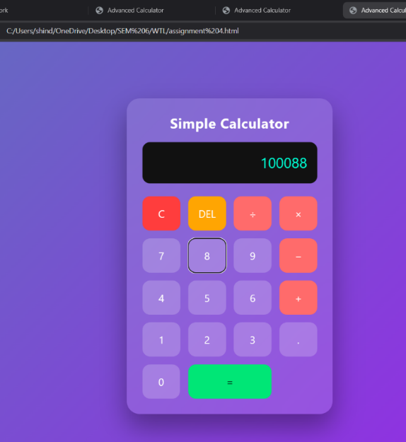
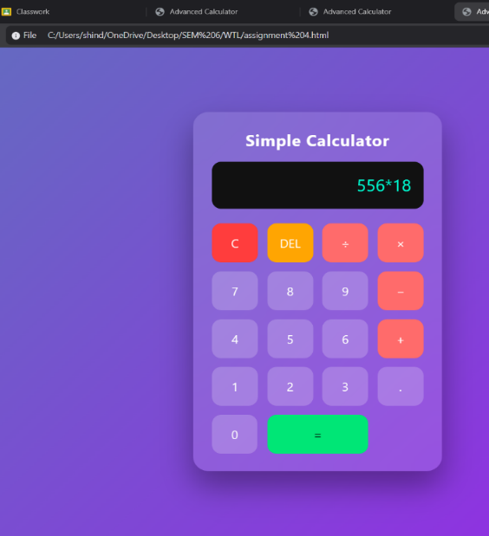
--Output:

